8

The bulb in the first circuit below (circuit a) is lit.
For each of the other circuits, tick one box () to show if the bulb is lit or not.

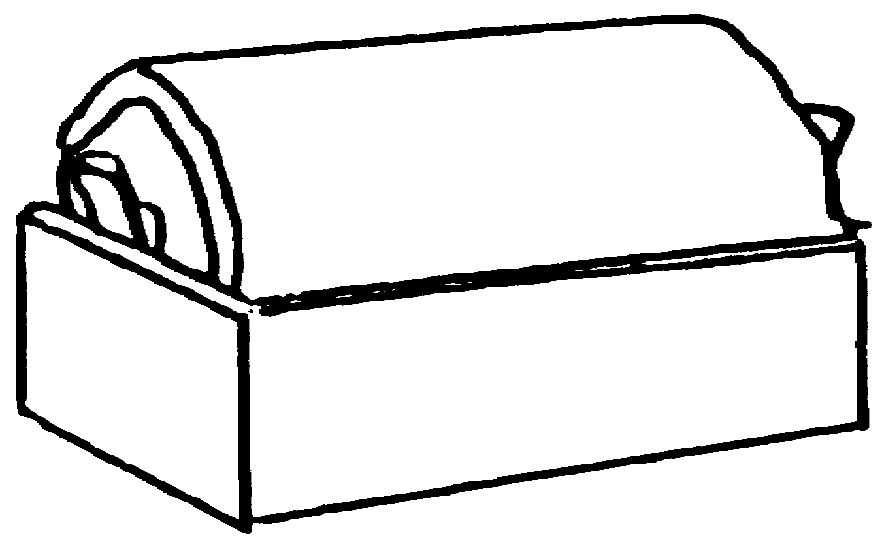
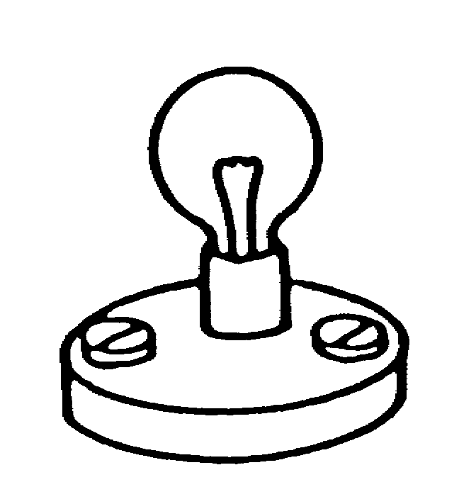
a. b.
not lit
lit

not lit
lit
.

.



c. d.

not lit
lit
not lit
lit
.

.

not lit
lit
not lit
lit
e. f.

.

.

